Chapter 1
LO: to use full stops and capital letters appropriately.

The Iron Man: ch 1
1. Read the passage below. Copy in your book and put in the full-stops and capital letters to summarise what has happened in the story so far.
there was a man standing on a cliff the man was made of iron there was darkness all around his head was as big as a dustbin his eyes were like headlamps, he jumped off the cliff and landed on the beach with a crash his arms and legs fell off
2. Write examples of figurative language you spotted in this chapter (alliteration, simile, onomatopoeia, etc)
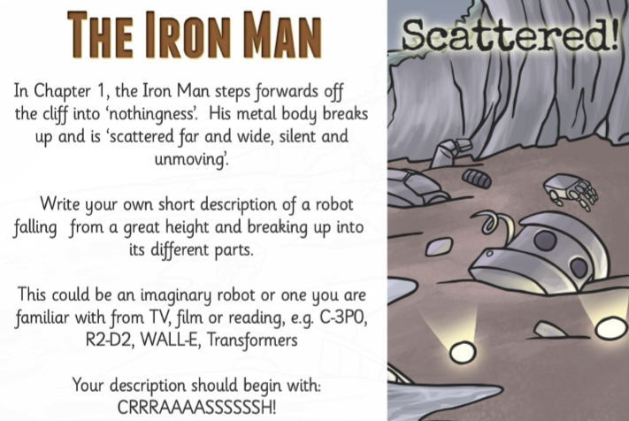
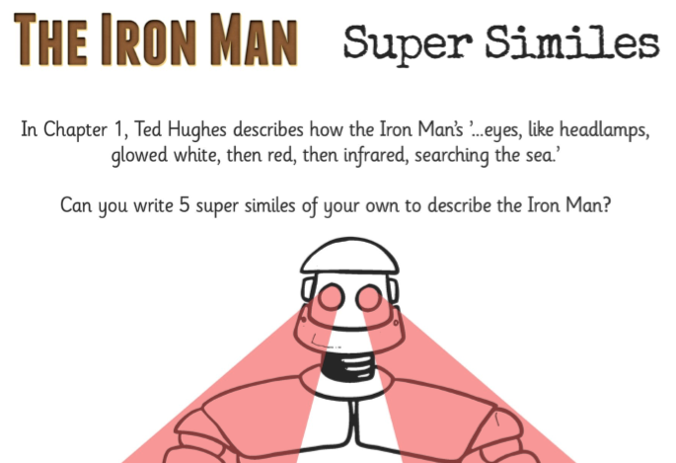
LO: answer questions about a text.

The Iron Man: ch 1.part 2
1) What does the following sentence mean? ‘The wind sang through his iron fingers.’

2) Why were his eyes shining different colours?

3) Why did he step off the cliff?

4) How did the seagull spot the Iron Man’s hand and eye?

5) What did the seagulls think they had found?

6) Where was the Iron Man’s missing ear?

7) Why did the Iron Man walk into the sea?

8) Why do you think the seagulls were circling over the Iron Man as he walked into the sea?

